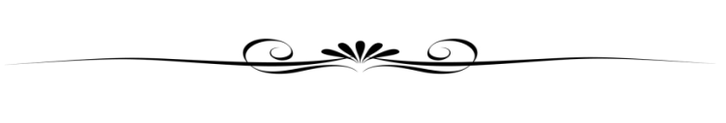

Proclamation

TITLE

WHEREAS, XXX; and
WHEREAS, XXX; and
WHEREAS, XXX; and
WHEREAS, XXX; and
WHEREAS, XXX; and
WHEREAS, XXX.
NOW, THEREFORE I, ________, Mayor of the City of Palo Alto, do hereby commend __________ for _______________.

Presented: Date

______________________________
Name
Mayor

