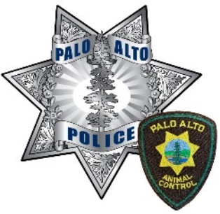
PALO ALTO ANIMAL CONTROL
SERVICE DOG AFFIDAVIT

By affixing my signature to this affidavit, I hereby declare I fully understand that Section 365.7 of the Penal Code prohibits any person to knowingly and fraudulently represent himself or herself, through verbal or written notice, to be the owner or trainer of any canine licensed as, to be qualified as, or identified as, a guide dog, signal dog, or service dog, as defined in subdivisions (d), (e), and (f) respectively of Section 365.5 of the Penal Code and paragraph (6) of subdivision (b) of Section 54.1 of the Civil Code, and that a violation of Section 365.7 of the Penal Code is a misdemeanor punishable by imprisonment in a county jail not exceeding six months, by a fine not exceeding one thousand dollars ($1,000) or by both imprisonment and fine.

Signature | Date:

PENAL CODE SECTION 3.65

(d) As used in this section, “guide dog” means any guide dog or Seeing Eye dog that was specifically trained by a person licensed under Chapter 9.5 of Division 3 of the Business and Professional Code that meets the definitional criteria under federal regulations adopted to implement Title III of the Americans with Disabilities Act of 1990.
(e) As used in this section, “signal dog” means any dog trained to alert a deaf person, or person whose hearing is impaired, to intruders of sounds.
(f) As used in this section, “service dogs” means any dog individually trained to do work or perform tasks for the benefit of an individual with a disability, including, but not limited to, search and rescue work, pulling a wheelchair or fetching dropped items.
FOOD AND AGRICULTURE CODE SECTION 30850(c)

Upon death or retirement of an assistance dog, the owner or person in possession of the assistance dog identification tag shall immediately return the tag to the animal control department that issued the tag.

SERVICES

Please describe what tasks this dog is trained to perform.
______________________________________________________________________________________________
______________________________________________________________________________________________
______________________________________________________________________________________________
______________________________________________________________________________________________
______________________________________________________________________________________________
______________________________________________________________________________________________
______________________________________________________________________________________________

